Module Name: login page
Test Case ID:1
Webpage URL:https://practicetestautomation.com/practice-test-login/

Scenario ID: 1
Scenario: sign up with valid id password
Test Steps:
1.open login page
2.enter username
3.enter a password
4.click on login button
Screenshots:
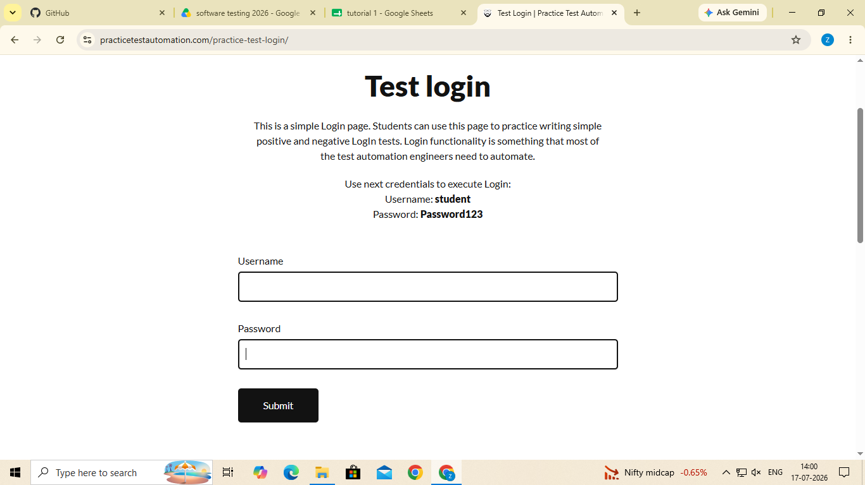
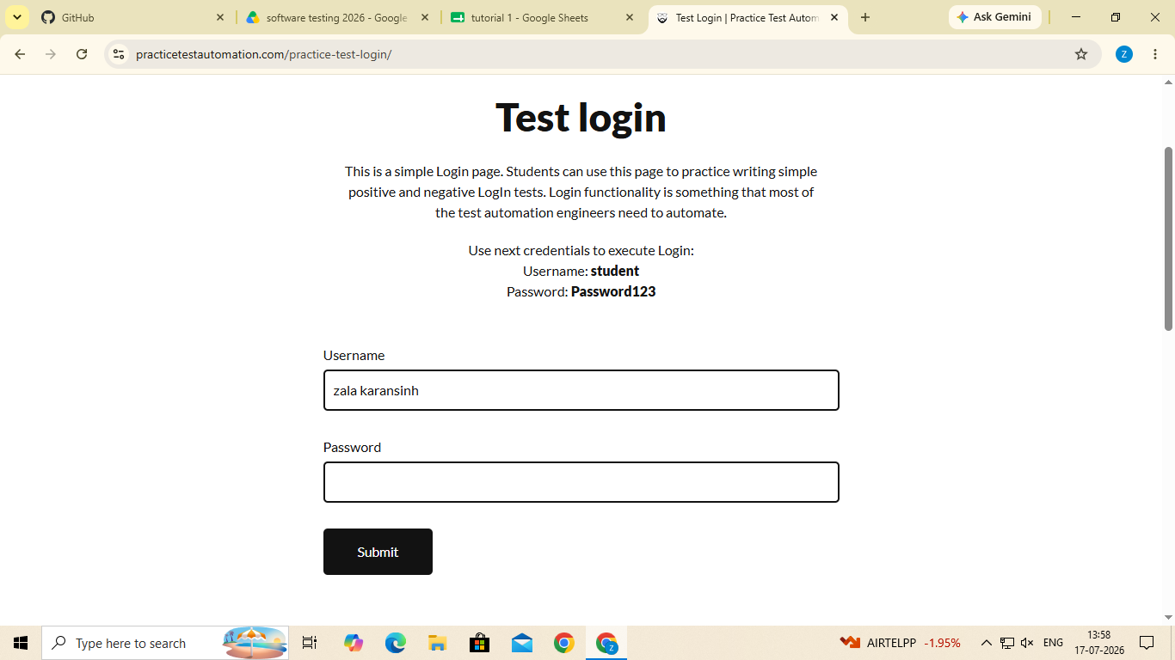

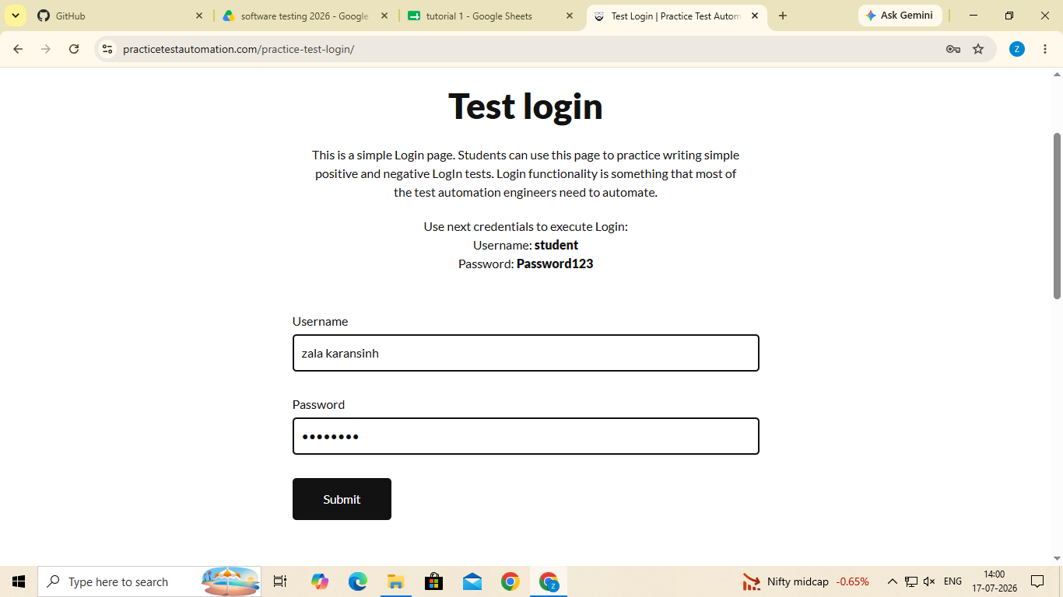
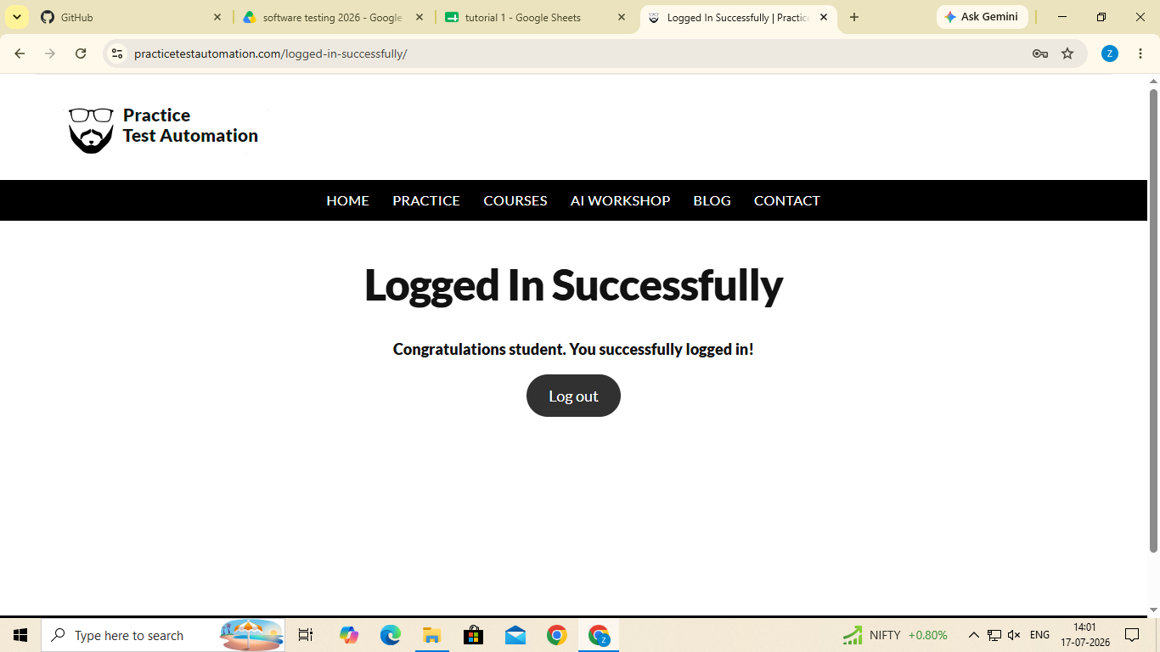

Scenario ID: 2
Scenario: invalid username & password
Test Steps:
1.open login page
2.enter username
3.enter a password
4.click on login button
Screenshot :

